1.8

Trading of stocks.

1. Low closer trading
2. Ensure trend pnl is stable (flat or up)
3. No adding when wtd pnl is negative.

Fut opened at 0.7 premium.

Last week trend pnl was up every single day.

After crash on Dec 27 (wed), market has risen about 4%.

Moutai still the strongest and most suitable for intraday trading.

Future sentiment change:

First stage: fut is overvalued and traders optimistic. (PD 0.8) (OPT)

Second Stage: PD goes back to normal (0.3) (NORMAL)

Third stage (PD 0.2): DP stabilizes, people taking opportunity to offload on index spike (PESSI)

@ Close:

高位横。Not good at this point.

1.10.2018

Blue chips broke their previous highs after the adjustment in late nov.

Funds start to build position again in the new year.

Market sentiment is very strong.

How to trade trend pnl continuation?

1. Trend pnl positive
2. Not owing any pnl

Some results on trend pnl, owed pnl

1. Trend pnl is 57% positive, owed pnl 58% positive (from Feb 2016 now, mostly bull market)
2. Positive trend is followed with positive with 56%. Negative trend flips positive with 59%.
3. Positive owed pnl is a gamble into the next session. Negative owed pnl flips to positive with 66%. (Advantage)
4. Seven day continuation is rare (happened last Jan 18-26 as well)

After market:

Trend pnl turns negative and ptf is owing pnl now.

Big caps is stronger than general market.

1.11

Look at Sharpe of stocks after index has peaked.

This is also when portfolio has peaked.

If individual stocks can display stronger Sharpe than index, that means it is investable.

Use 11/22 where

Market:

Starts off weak, trend pnl < 0.

Adjustment needed here after a 8 straight ups.

Gree is up 20% in Jan, such rapid advances can hardly continue.

When markets were adjusting, look for:

1. Best since-adjustment sharpe ratio.

1.15

Delayed weekly recap:

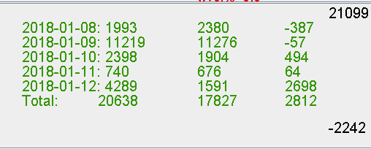

Trend pnl is up everyday which shows real position building is strong.

Short term traders are not making as much profits as the long termers.